STANDARD SPONSORSHIP FORM

https://legacycentermichigan.com

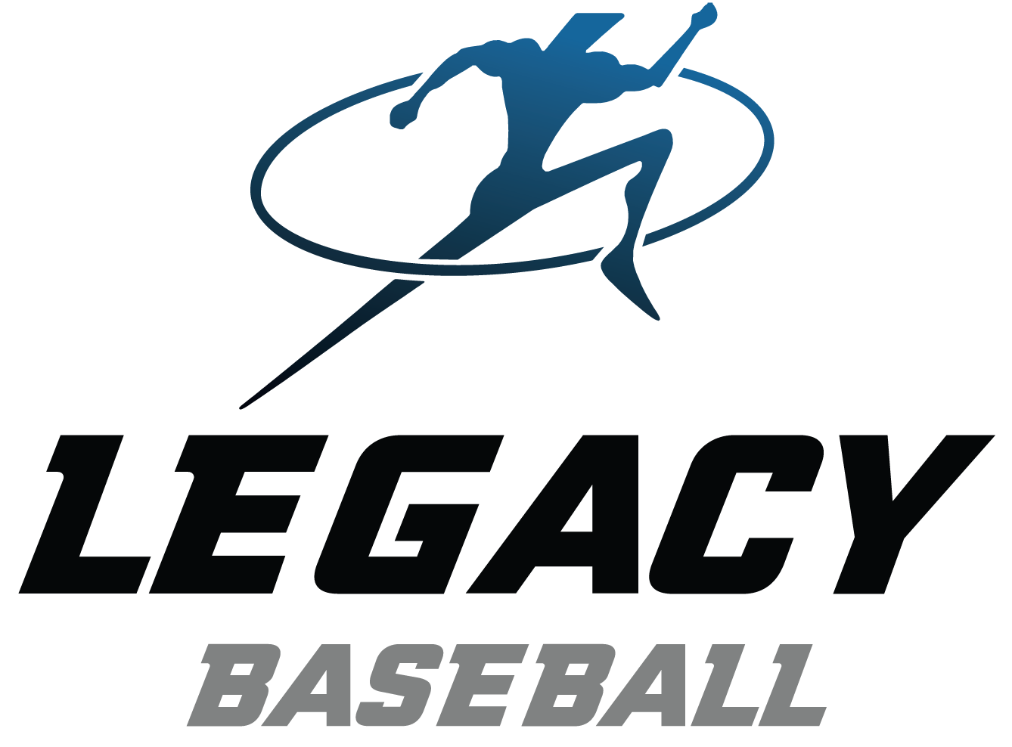
Sponsorship levels:

Bronze | • Business Logo on single Legacy Select Travel team banner | $ 250
Silver | • Business Logo on all Legacy Select Travel team banners | $ 800
Gold | • Larger size Business Logo on all Legacy Select Travel team banners | $1,500

(100% of your sponsorship goes to support the players)

- Logo’s MUST be emailed to Scott Theisen at stheisen@legacycentermichigan.com.

- Please make your check payable to “Legacy Center” or call and use a credit card.

C. Please mail this form and payment to the address below:

Checks may be made out & sent to: Legacy Center Baseball
Attn: Scott Theisen
9299 Goble Dr.
Brighton, MI 48116

Player: __________________________ Team:

(Team Age and Head Coach)

Sponsoring Business/Organization:

RECEIPT – keep this portion for your records

Thank you for your support of Legacy Travel Players by purchasing a banner sponsorship.
Your sponsorship level is as follows:

Bronze | • Business Logo on single Legacy Select Travel team banner | $ 250
Silver | • Business Logo on all Legacy Select Travel team banners | $ 800
Gold | • Large size Business Logo on all Legacy Select Travel team banners | $1,500

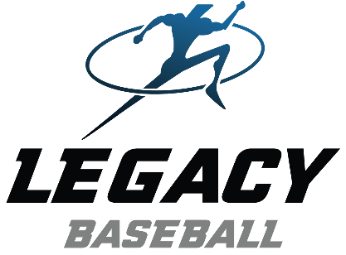
Thank you for your support!
Scott Theisen
Legacy Baseball Director

