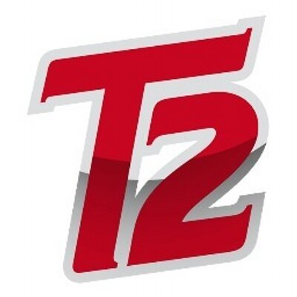
NON-PROFIT SPONSORSHIP FORM
(90% to Player and 10% to L.E.A.D.)
https://legacycentermichigan.com

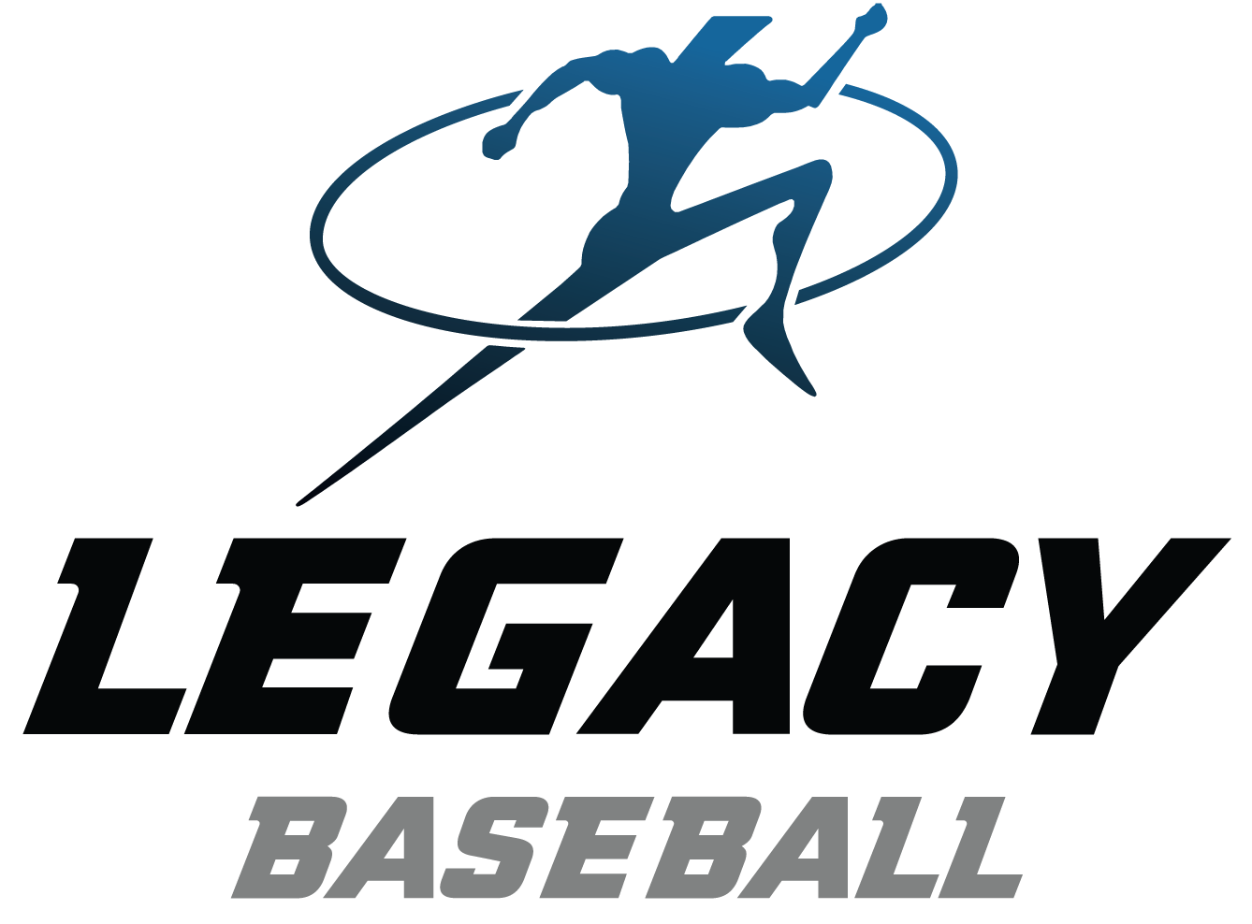
Sponsorship levels:

Bronze  Silver | • Small Business Logo on single Legacy Select Travel team banner | $ 250
Silver  G | • Small Business Logo on ALL Legacy Select Travel team banners | $ 800
Gold | • Larger size Business Logo on ALL Legacy Select Travel team banners | $1,500

(100% of your sponsorship goes to support the players)

- Logo’s MUST be emailed to Scott Theisen at stheisen@legacycentermichigan.com.

B. Please make your check payable to “L.E.A.D.”.

C. Please mail this form and payment to the address below.
Checks may be made out & sent to: Legacy Center Baseball
Attn: Scott Theisen,
9299 Goble Drive
Brighton, MI 48116

Player: __________________________ Team:

(Team Age and Head Coach)

Sponsoring Business/Organization:

RECEIPT – keep this portion for your records

Thank you for your support of Legacy Travel Players by purchasing a banner sponsorship.
Your sponsorship level is as follows:

Bronze  Silver | • Business Logo on single Legacy Select Travel team banner | $ 250
Silver  G | • Business Logo on ALL Legacy Select Travel team banners | $ 800
Gold | • Large size Business Logo on ALL Legacy Select Travel team banners | $1,500

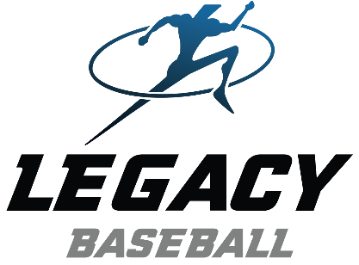
Thank you for your support!
Scott Theisen
Legacy Baseball Director

